**STRING ASSIGNMENT**

1.Write an application to determine the length of the String str - “Hello world”.

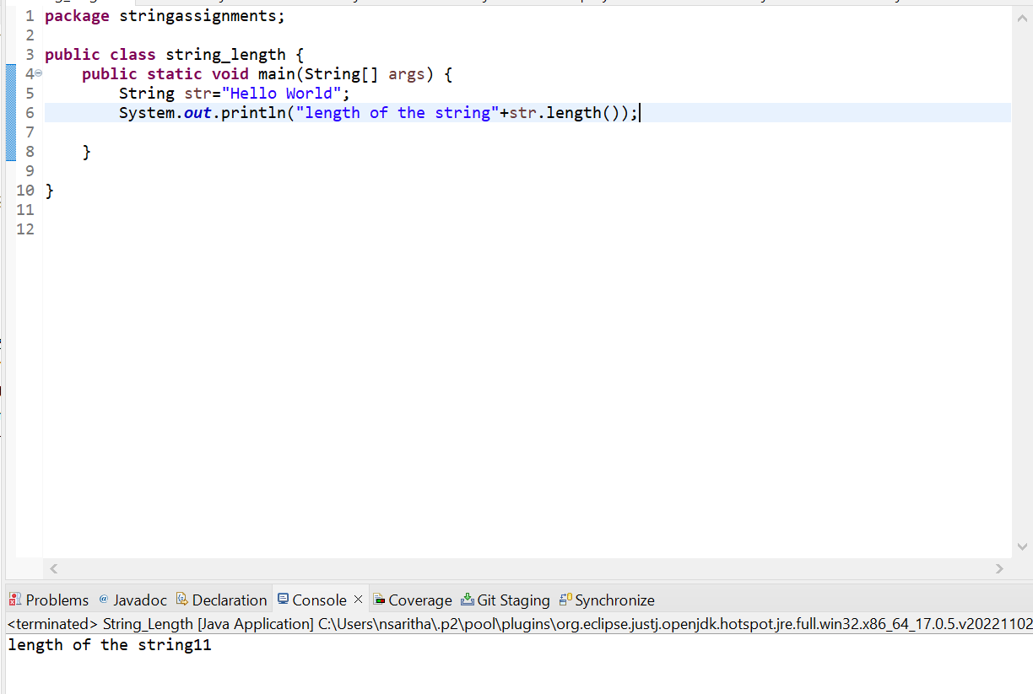

2.Write an application to join the two Strings “Hello,”&”How are you?”.

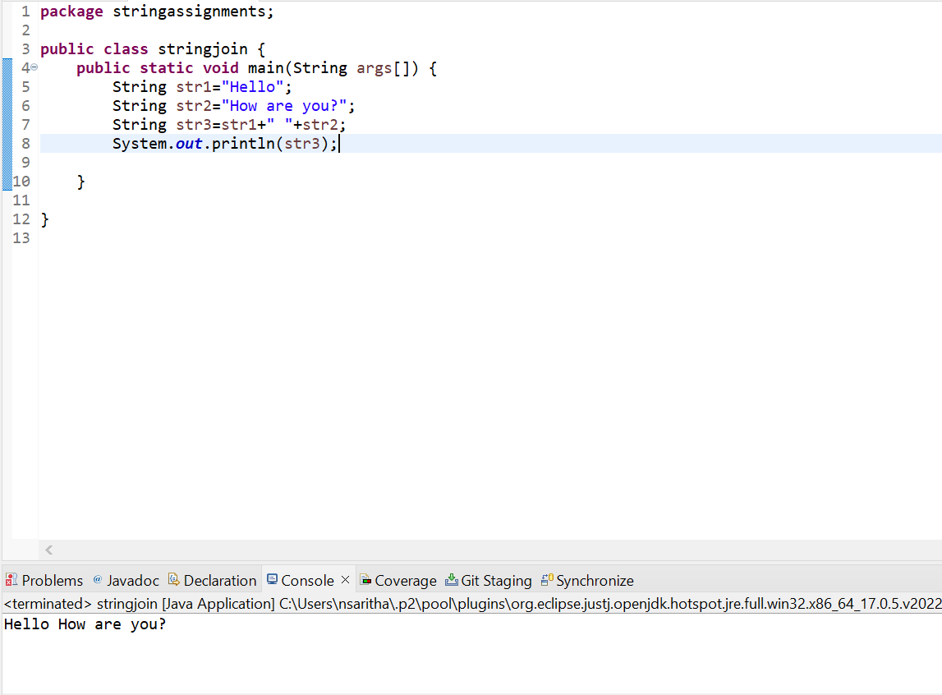

3.Given a String “java String pool refers to collection of Strings which are stored in heap memory”, Perform the following operation.

A. Print the string to console in lowercase

B. Print the string to console in uppercase

C. Replace all ‘a’ character in the string with- S sign

D. Check if the original string contains the word ”Collection”

E. Check if the following string ”Java string pool refers to collection of strings which are stored in heap memory” matches the original

F. If the string does not match check if there is another method which can be used to check if the Strings are equal

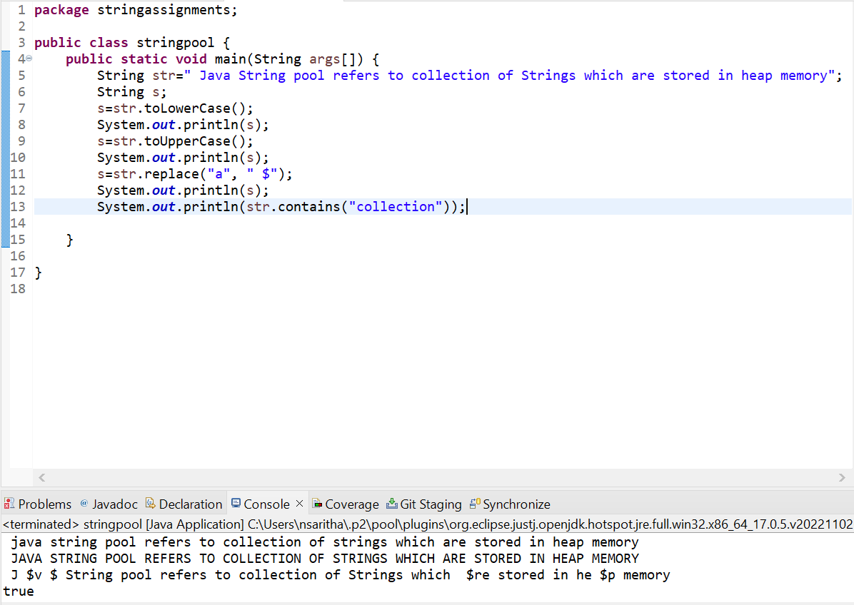

**Assignments on StringBuffer class**

1.write an application to append the following strings ” StringBuffer ”,”is a peer class of string”,”that provides much of ”,”the functionality of strings” using a StringBuffer.

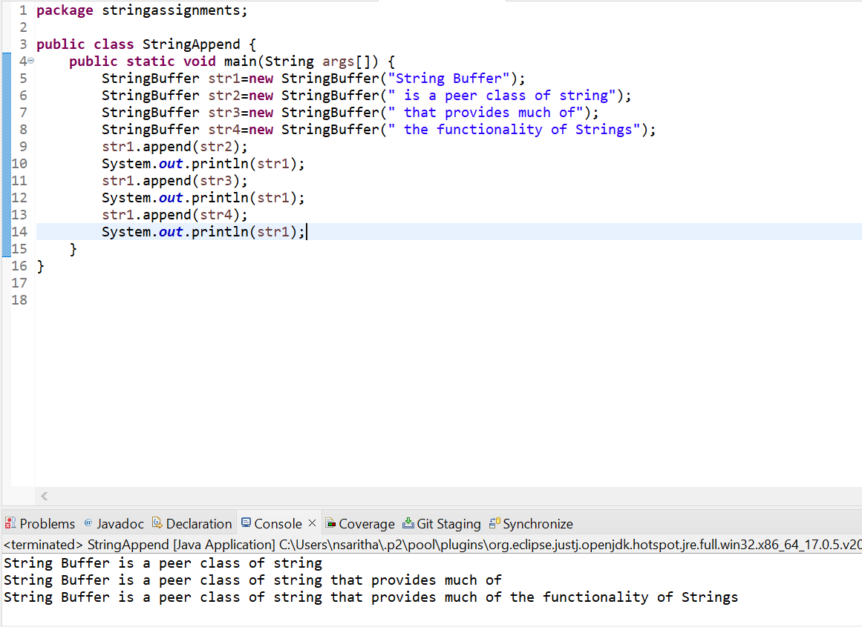

2.Insert the following string ”Insert text” into the strings ”It is used to_at the specified index position” at the location denoted by the sign_

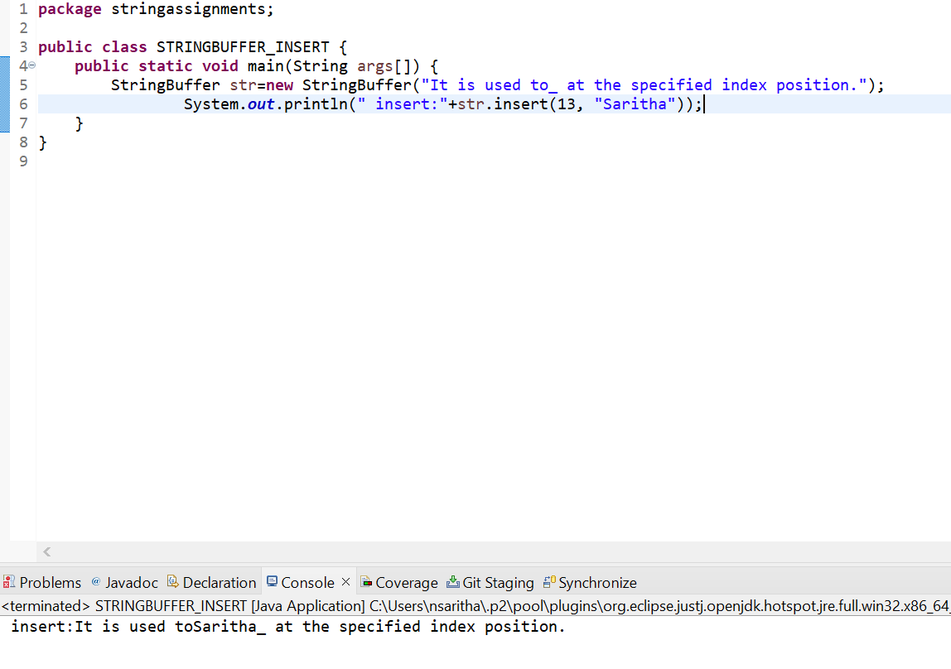

3.Reverse the following string ”This method returns the reversed object on which it was called” using StringBuffer class.

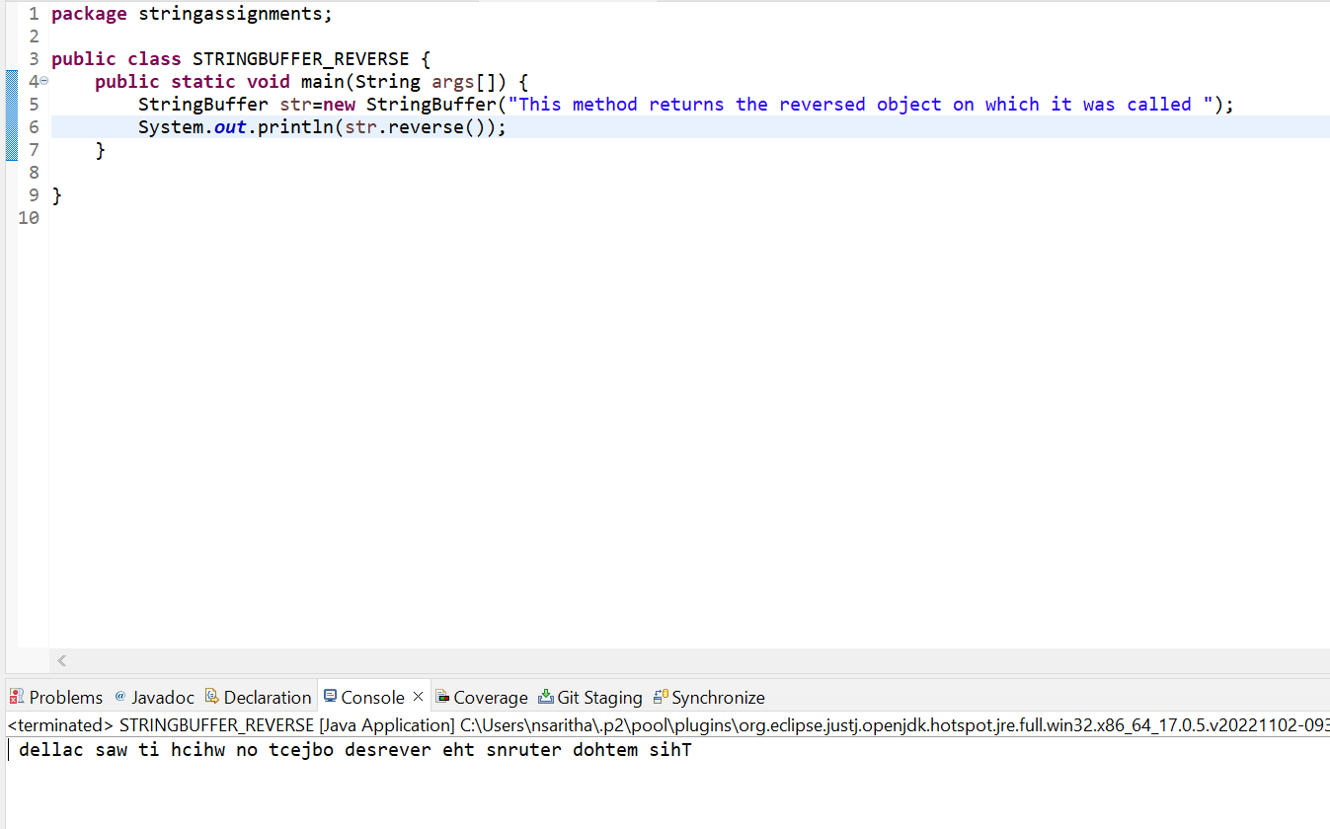

**Assignment on StringBuilder class**

1.write an application to append the following strings ” StringBuilder”,”is a peer class of string”,”that provides much of ”,”the functionality of strings” using a StringBuilder.

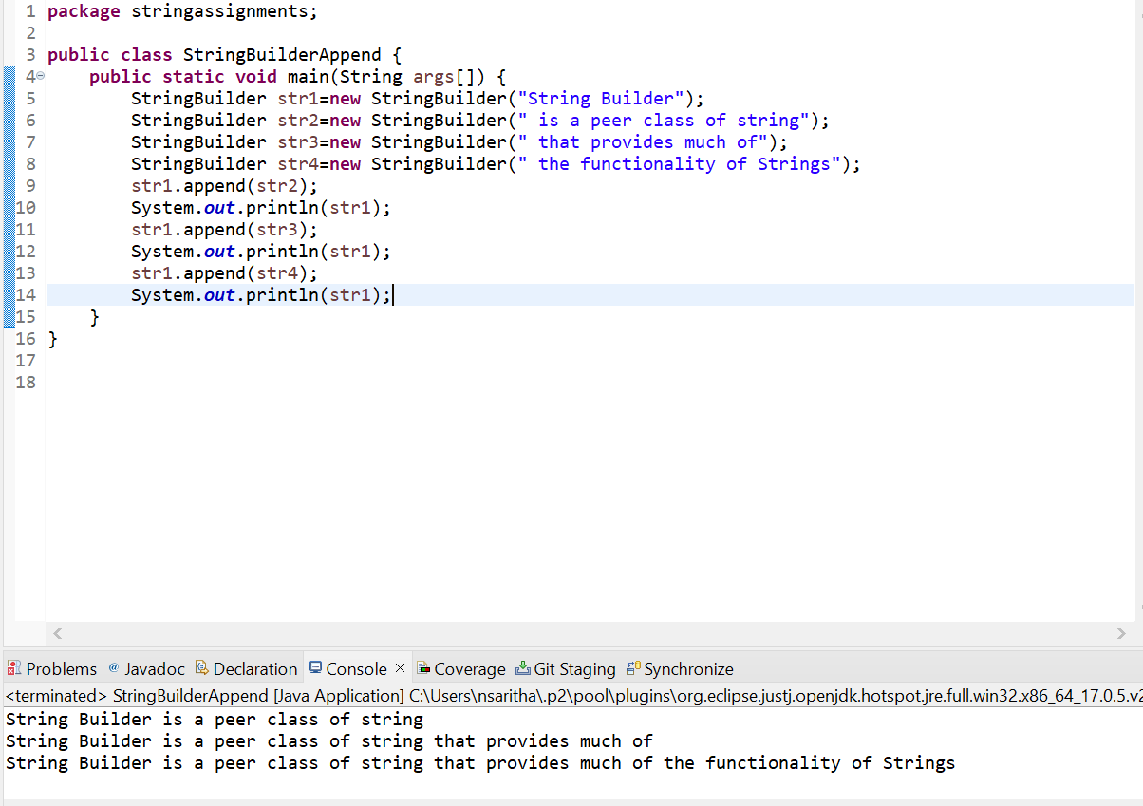

2.Insert the following string ”Insert text” into the strings ”It is used to_at the specified index position” at the location denoted by the sign_

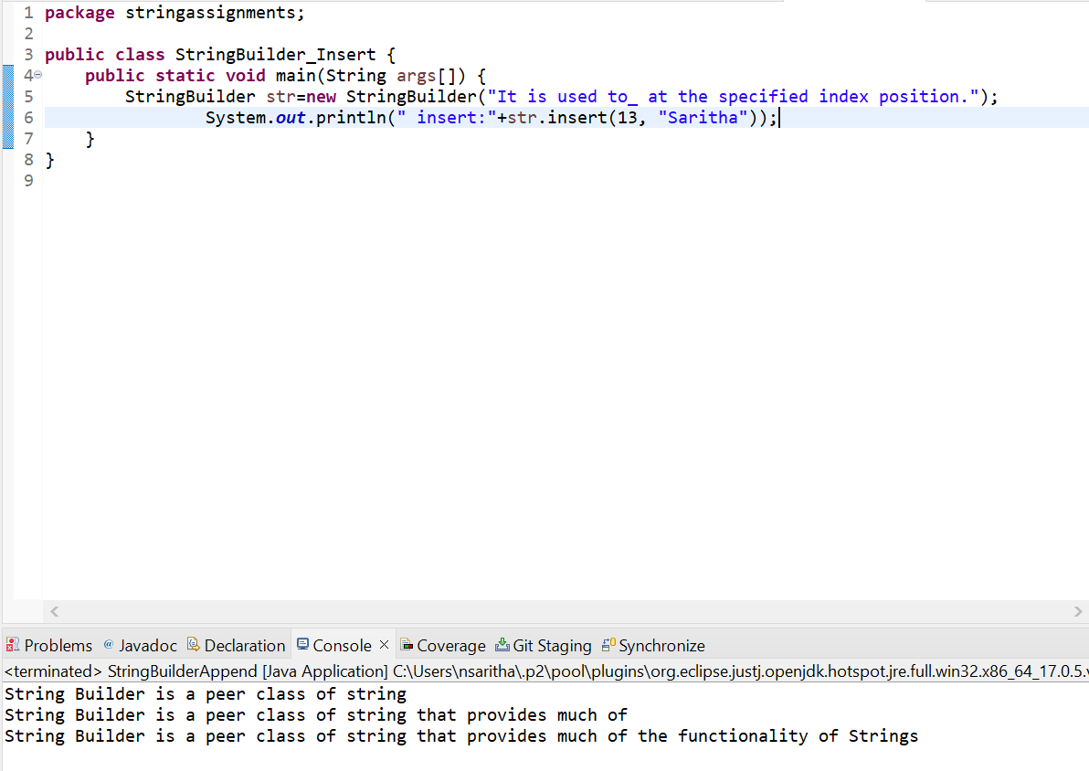

3.Reverse the following string ”This method returns the reversed object on which it was called” using StringBuilder class.

